# Lab: Creating a Blog with Spring MVC, JPA and MySQL

In this lab we shall create a fully-functional **Blog system** from scratch using **Spring MVC** and **MySQL** database. The blog holds posts (visible for everyone). Registered users (after login) can create / edit / delete posts. The blog will use Java, Spring Framework, Spring MVC, Thymeleaf template engine, Spring Data JPA, JPA, Hibernate and MySQL. This tutorial is part of the [“Software Technologies” course @ SoftUni](https://softuni.bg/courses/software-technologies).

# What We Are Building?

We are building a **Blog system** where users can view posts and create / edit / delete posts after registration / login.

## Blog System – Project Specification

Design and implement a **“Blog” Web application** in Spring MVC + MySQL. Implement the following functionality:

* **Home**
  + Show the **last 3 posts** at the home page, ordered by date (from the most recent).
  + Show also the **last 5 post titles** at the home page (as a **sidebar**) with a link to the post.
  + Show **[Login]** and **[Register]** buttons (when no user is logged in).
* **Login**
  + Login in the blog with existing account (username + password).
  + Show a success message after login or error message in case of problem.
* **Register**
  + Register a new user in the MySQL database (by username + password + full name).
  + Show a success message after registration or error message in case of problem.
* **Logout**
  + Logout the current user.
  + This [Logout] button is available after successful login only.
* **View / Create / Edit / Delete Posts (CRUD Operations)**
  + Logged in users should be able to **view** all posts, **create** new post (by title + content) / **edit** / **delete** their own posts.
  + Posts are **displayed in a table** (one row for each post). At each row a link **[Edit]** and **[Delete]** should be displayed.
  + **Create post** shows a **form** to enter the post data (title + content). After the form submission, the post is created in the database. Implement field validation (non-empty fields are required).
  + **Edit post** fills an existing post data in a form and allows it to be edited. After successful form submission, the post is edited. Implement field validation.
  + **Delete post** shows the post to be deleted and asks for confirmation.
* **View All Users**
  + Logged in users should be able to **view** all users (username + full name) in a table.

## Blog System – Screenshots

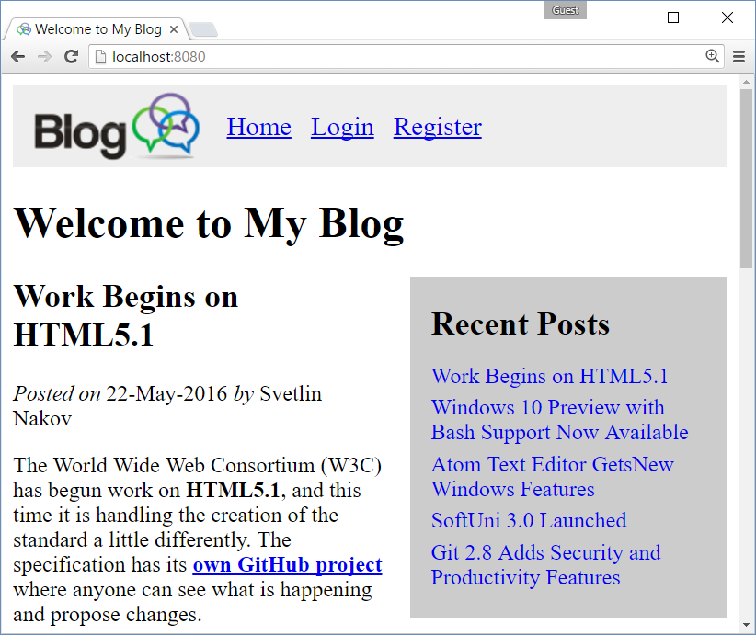

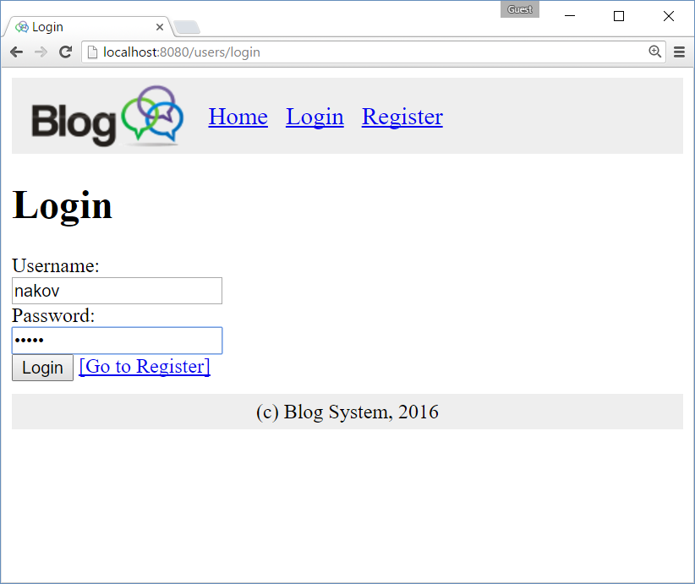

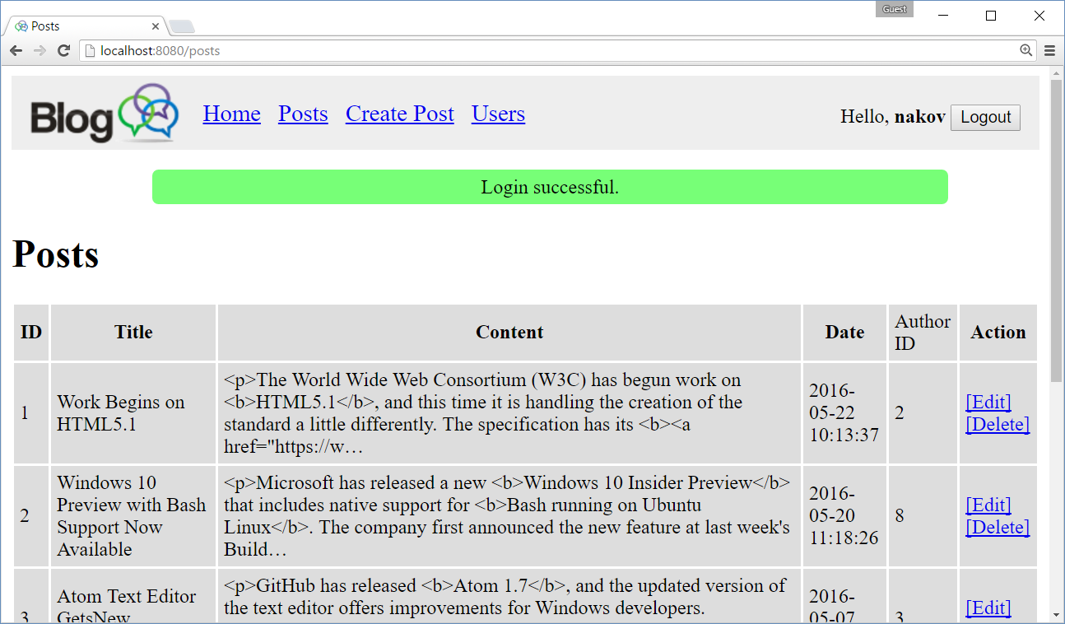

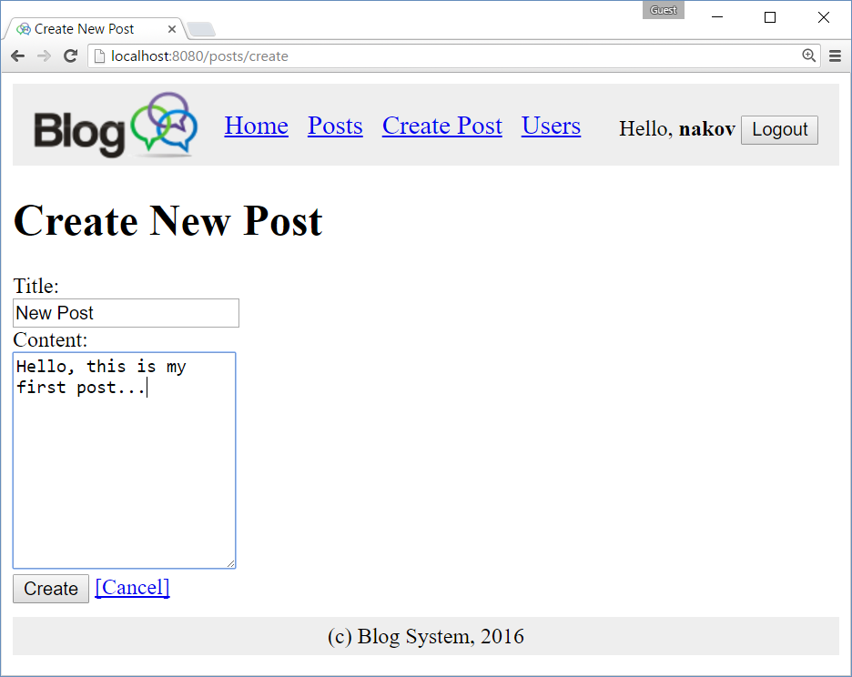

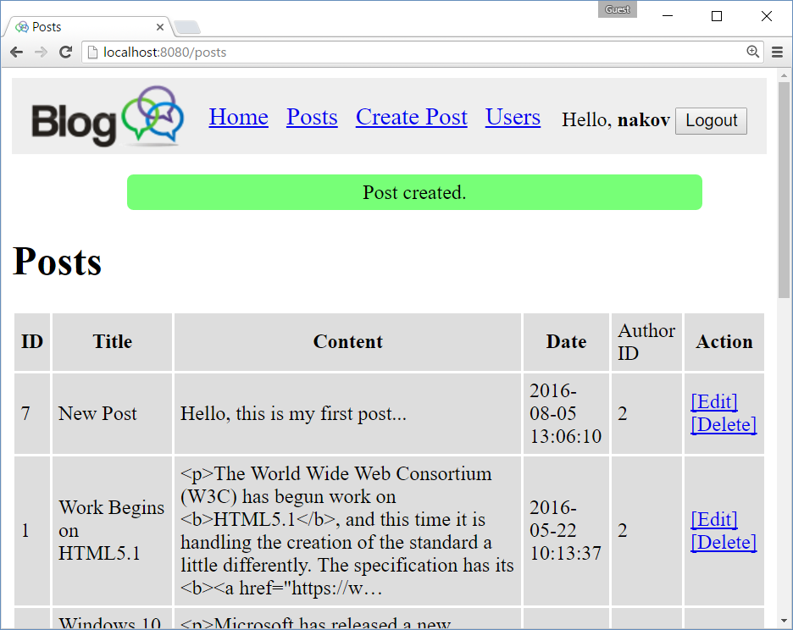

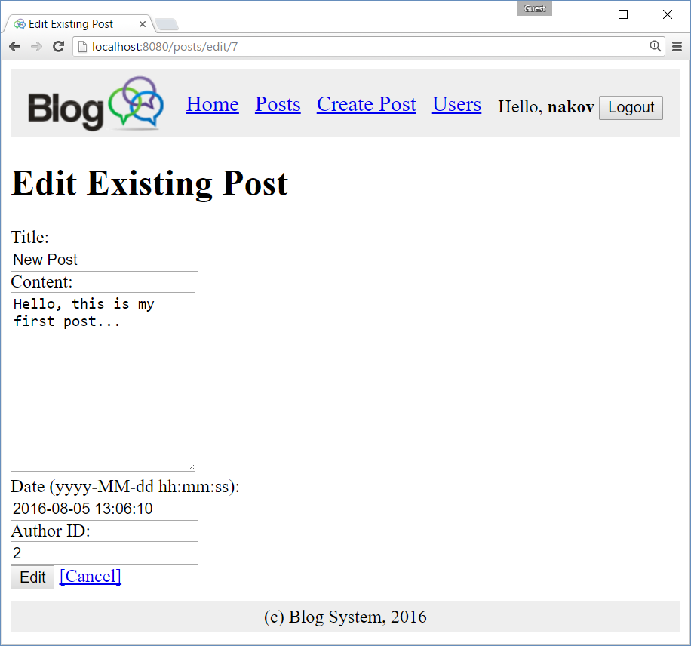

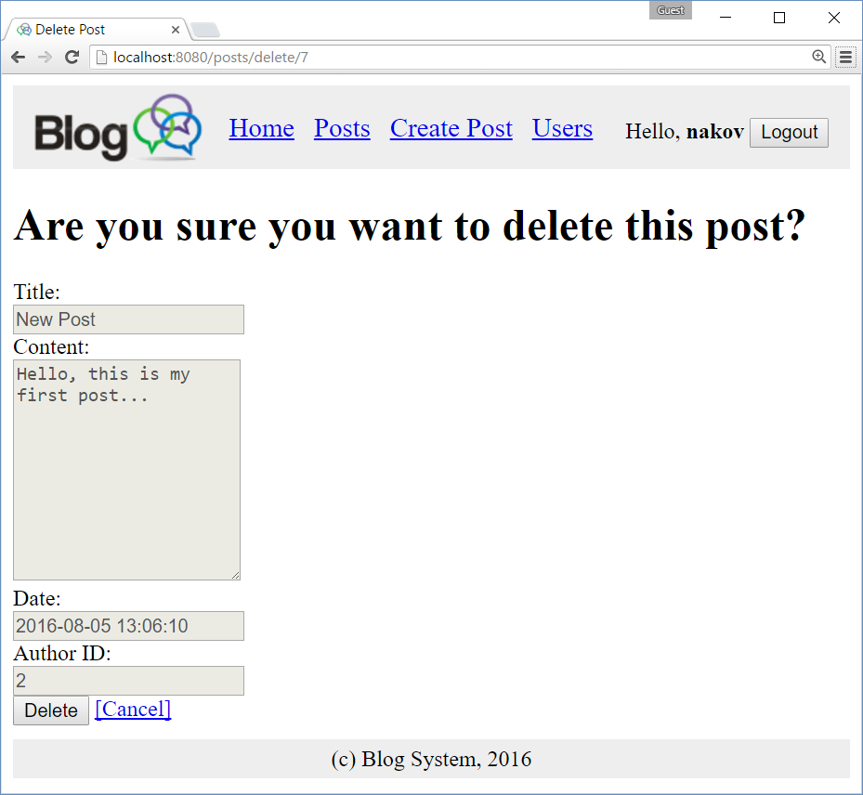

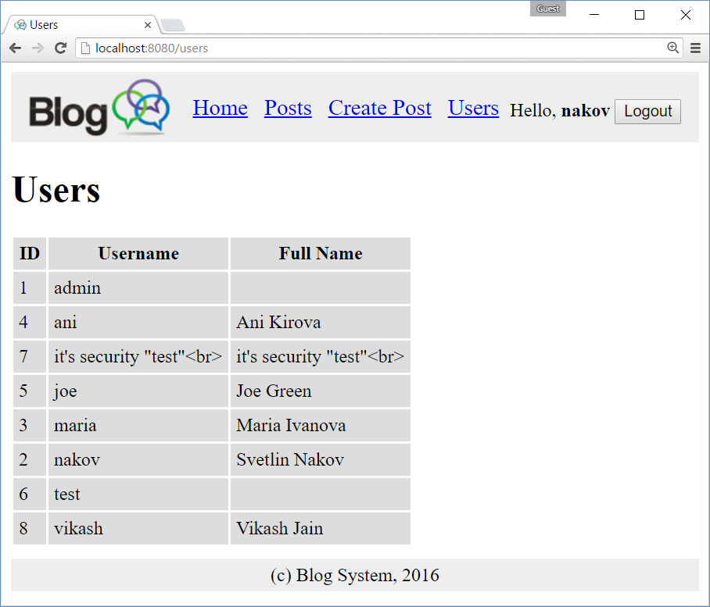

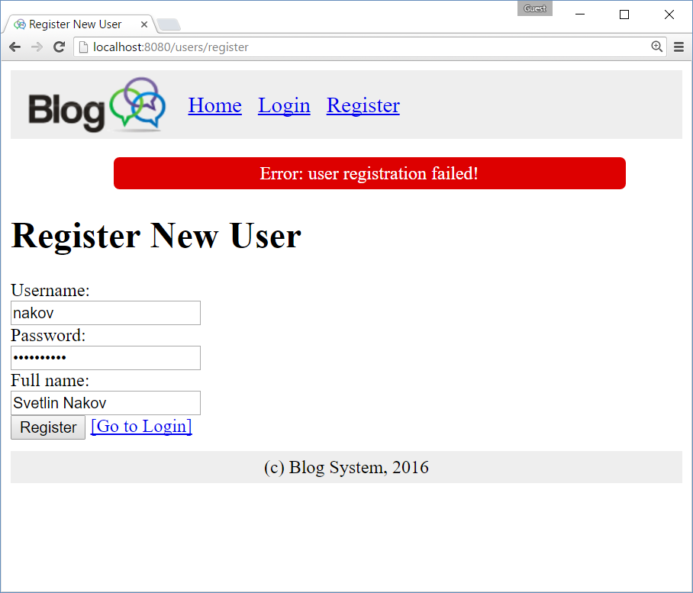

# Part I: Setup a Spring Boot Project

In this section we shall create an empty **Spring MVC application** based on **Spring Boot** using **Maven**.

We shall use **IntelliJ IDEA** as development environment, but Eclipse or any other Java IDE could work as well.

## Create a New Maven Project

Create a new **Maven project** for the Blog system:

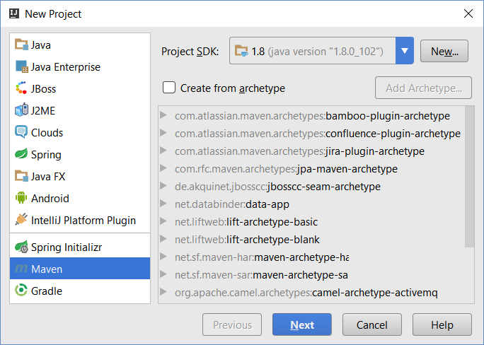

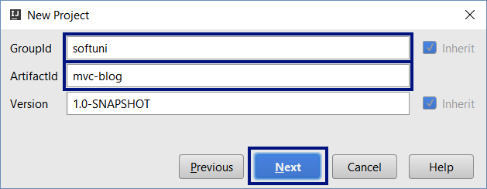

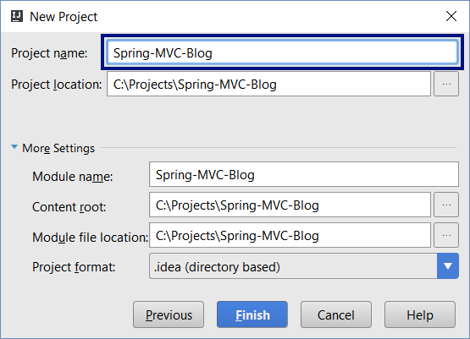

The IDE will create for you а Maven configuration file pom.xml in the project root folder. In IntelliJ IDEA enable the “auto-import” for the Maven dependencies.

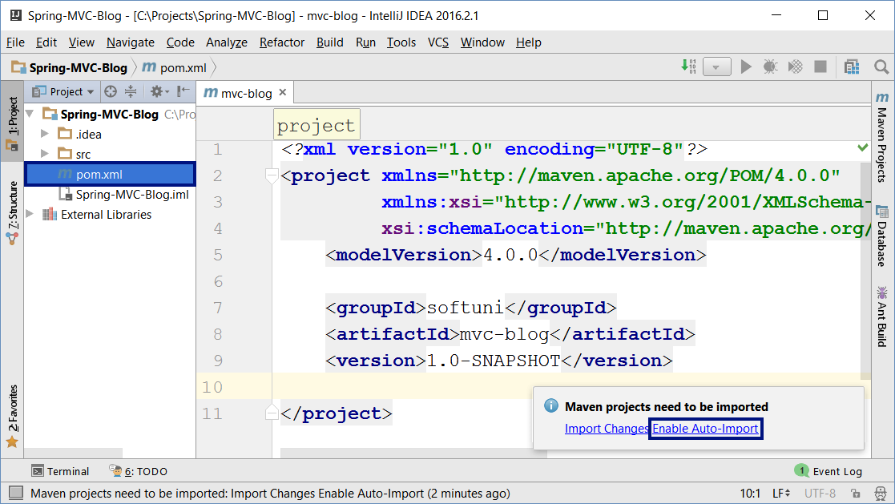

## Add the Spring Boot Dependencies in Maven

Inside the <project> element in the pom.xml add the spring-boot-starter-parent dependency:

|  |
| --- |
| **pom.xml** |
| <**parent**>  <**groupId**>org.springframework.boot</**groupId**>  <**artifactId**>**spring-boot-starter-parent**</**artifactId**>  <**version**>1.4.0.RELEASE</**version**>  </**parent**> |

The above declaration inherits all [**Spring Boot**](http://projects.spring.io/spring-boot/) libraries and project settings from spring-boot-starter-parent. We will assign the Spring Framework **version** only once at this place. We shall use version **1.4.0** – the latest stable release as of August 2016. All other Maven dependencies will be without an explicitly specified version, so Maven will detect the required version automatically.

Add also a dependency to spring-boot-starter-thymeleaf:

|  |
| --- |
| **pom.xml** |
| <**dependencies**>  <**dependency**>  <**groupId**>org.springframework.boot</**groupId**>  <**artifactId**>**spring-boot-starter-thymeleaf**</**artifactId**>  </**dependency**>  </**dependencies**> |

The above code will configure the [**Thymeleaf**](http://www.thymeleaf.org/) **templating engine** that will be used for the views

Set the **Java version** to **1.8**. Otherwise the project will use old Java version and some functionality will not compile:

|  |
| --- |
| **pom.xml** |
| <**properties**>  <**java.version**>**1.8**</**java.version**>  </**properties**> |

This is how your Maven configuration file pom.xml might look like. Note that if everything is OK, the project libraries will include all **Spring Core**, **Spring Boot**, **Spring MVC** and **Thymeleaf** libraries (**jar** files, shown on the left):

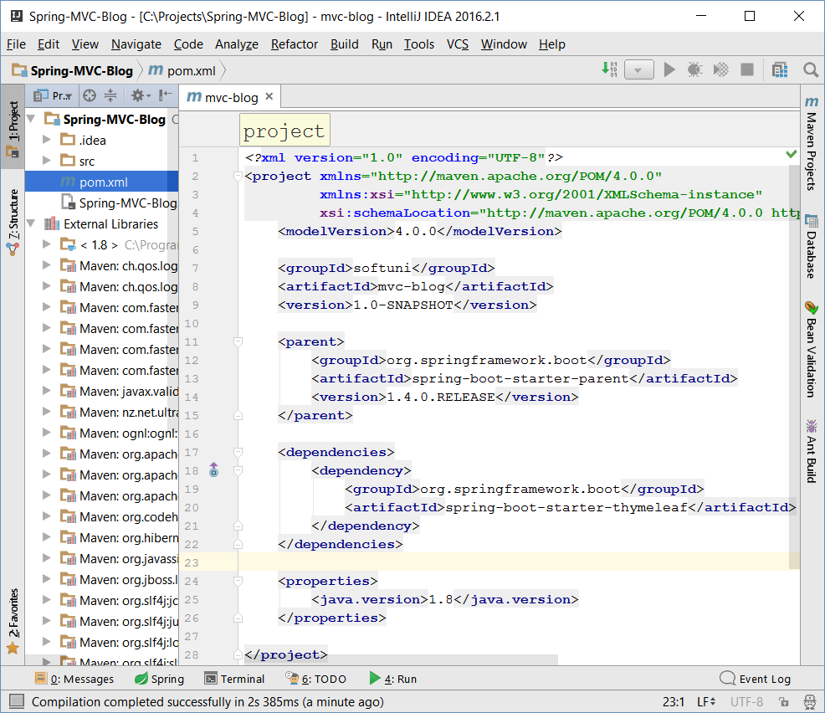

## Create the Project Structure: Directories

Create a package “blog” in the source code root of your Java project: src/main/java:

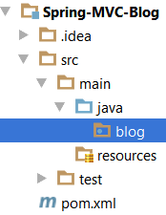

Create the following **packages** (directories) in src/main/java/blog:

* models – will hold the project **MVC models** (entity classes) like User and Post.
* controllers – will hold the project **MVC controllers** that will serve the blog functionality.
* services – will hold the **business logic** of the project, invoked by the controllers.

Create the following **folders** in src/main/resources:

* templates – will hold the application **views** (the Thymeleaf HTML templates and template fragments).
* public – will hold static HTML content like **CSS**, **images** and **JavaScript** code.
* public/img – will hold the site **images** (e.g. site logo).
* public/css – will hold the site **CSS** styles.
* public/js – will hold the site **JavaScript** files (e.g. jQuery, Bootstrap and custom JS code).

Your **project directory structure** should look like this:

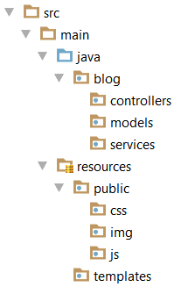

## Create the Project Structure: Files

Create a few important **project** **files** in src/main/resources:

* public/css/styles.css – the main **CSS styles** for the application. You shall put some style in this file later, so leave it empty now.
* public/img/site-logo.png – the site **logo**. Copy it from the resources coming with this tutorial.
* public/img/favico.ico – the browser **icon** for the site. Copy it from the resources for this tutorial.
* public/js/blog-scripts.js – the **JavaScript code** that will be used in our blog. You shall put some JS code in this file later, so leave it empty now.
* public/js/jquery-3.1.0.min.js – the **jQuery** library that will simplify your JS code. Copy it from the resources for this tutorial or from Internet: <https://jquery.com/download/>.
* application.properties – the Spring **application settings** (like logging configuration and database connection settings). Initially, leave this file empty.

After completing all the above steps, your **project resources file structure** should look like this:

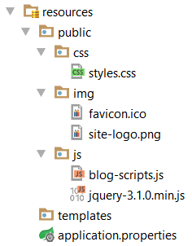

## Create the Spring Boot Application Startup Class

Create the **Spring Boot application startup class** in the package “blog” in your src/main/java directory:

|  |
| --- |
| src/main/java/blog/**BlogMvcApplication.java** |
| **package** blog;  **import** org.springframework.boot.SpringApplication; **import** org.springframework.boot.autoconfigure.SpringBootApplication;  **@SpringBootApplication** **public class** BlogMvcApplication {  **public static void** main(String[] args) {  SpringApplication.*run*(**BlogMvcApplication**.**class**, args);  } } |

This class configures and starts your Spring Boot application, which is still empty. The @SpringBootApplication annotation applies the default configuration settings for our Spring Boot application (finds and loads all entities, controllers, UI templates and other application assets). Calling SpringApplication.run(…) will start an embedded [**Tomcat Web application server**](http://tomcat.apache.org/) at <http://localhost:8080> to serve the HTTP requests to your Spring MVC Web application.

## Run the Empty Web Application

Now you are ready to **run your Web application** for the first time. Run the BlogMvcApplication class, just like any other Java program. It should show a long sequence of **logs** (informational messages) at its startup:

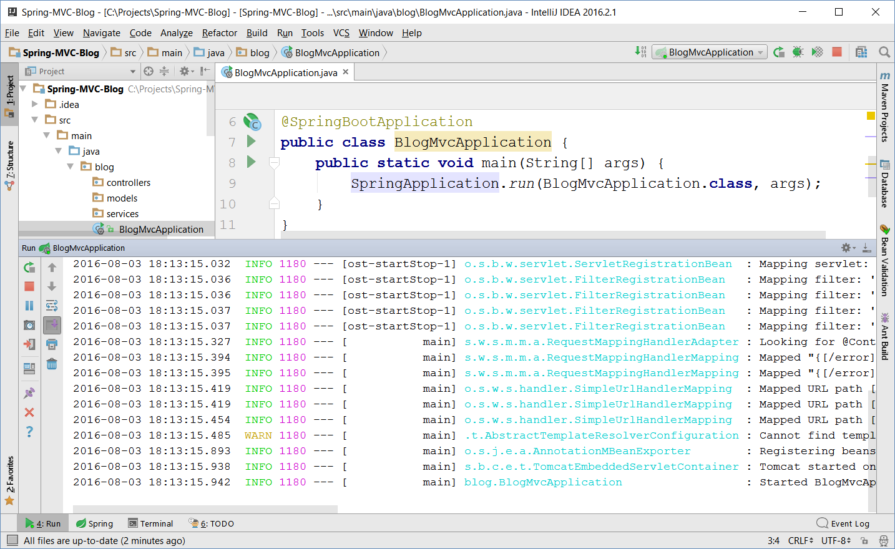

Open project URL at [**http://localhost:8080**](http://localhost:8080) in your browser to check **whether Tomcat and Spring MVC are running**. You should see a Web page like the shown below. Note the **green site icon** of the top left angle of the browser. This is the Spring Framework’s icon. If you see it, your browser shows a Spring MVC application.

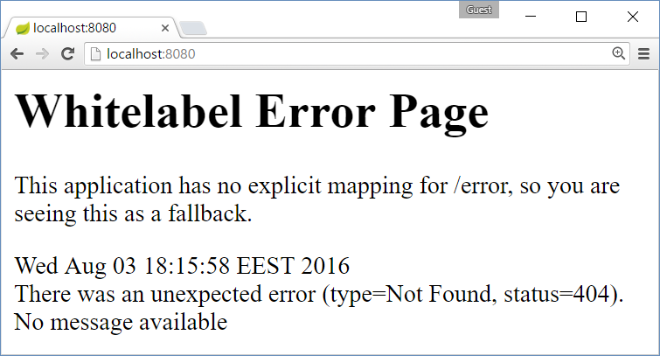

It is quite normal to see this **error message**. It says that the Embedded Tomcat server with Spring MVC is running, but you have **no registered controller action** to handle HTTP GET requests for your home page URL “/”.

If your browser shows you other Web content (e.g. different site icon), or fails to open localhost:8080, check for errors in your Java application output and also who is listening at port **8080** on your localhost loopback interface.

## Create the Home Controller + View

To ensure your **Spring MVC application** and the **Thymeleaf** templating engine are properly configured, create your first **controller** + **Thymeleaf view** and invoke it from your browser.

Create a Java class HomeController.java in your src/main/java/blog/controllers directory:

|  |
| --- |
| src/main/java/blog/controllers/**HomeController.java** |
| **package** blog.controllers;  **import** org.springframework.stereotype.Controller; **import** org.springframework.web.bind.annotation.RequestMapping;  @Controller **public class** HomeController {  @RequestMapping(**"/"**)  **public** String index() {  **return "index"**;  } } |

The above code defines a **Spring Web MVC controller** and defines an **action** that handles HTTP GET requests for the root URL of the project “/”. When someone opens <http://localhost:8080/> form a Web browser, the above action will be called. It returns the “index” view and this means to render a Thymeleaf template “index.html” located in the file src/main/resources/templates/index.html.

Create a **Thymeleaf view** “index.html” in your src/main/resources/templates directory:

|  |
| --- |
| src/main/resources/templates/**index.html** |
| <!DOCTYPE **html**> <**html xmlns:th="http://www.thymeleaf.org"**>  <**head**>  <**meta charset="UTF-8"** />  <**title**>Blog</**title**> </**head**>  <**body**>  <**h1**>Welcome to Spring MVC</**h1**>  Now is: <**b th:text="${execInfo.now.time}"**></**b**> </**body**>  </**html**> |

The above code is a sample **HTML page** that uses the **Thymeleaf view engine** to display the **current date and time**. The namespace **xmlns:th="http://www.thymeleaf.org"** indicates that this file is not pure HTML, but is a **Thymeleaf template** that should be processed at the server side to produce a HTML page.

## Restart the Web Server to See the Changes

Compile and **make your project** (press [Ctrl+F9] in IDEA) and **restart the Spring Boot Web server** to be able to see the changes in your code (the new controller + view). Stop and start again (or re-run) your Spring MVC application (the BlogMvcApplication class). In IntelliJ IDEA you have a special button to do this in the [Run] panel:

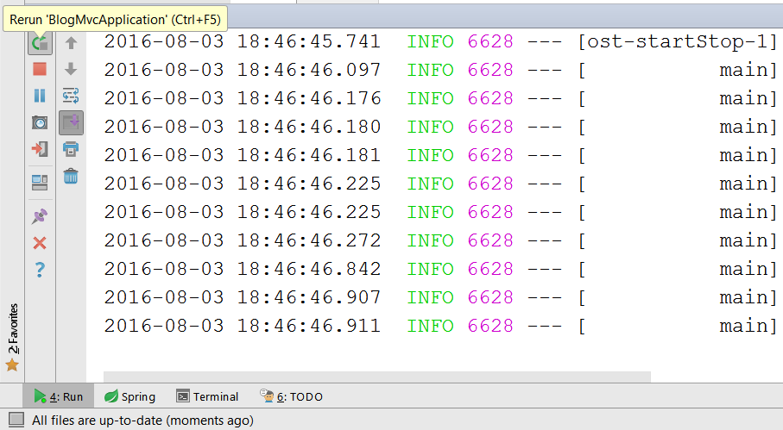

## See the Output from Your First Controller + View

Now refresh your Web browser or open again <http://localhost:8080>. You should see the **HTML output** from your first MVC **controller action** + Thymeleaf **view**. It should look like this:

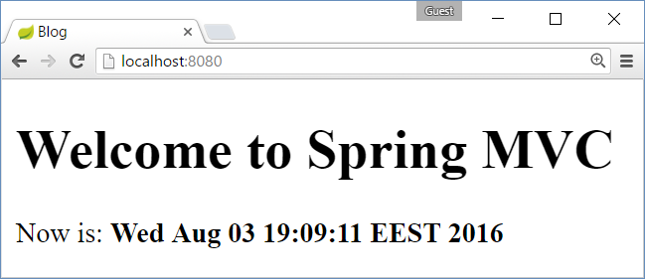

## Configure Auto-Reload after Change in the Source Code

It is quite ugly to **rebuild** your project and **restart** your Web server manually each time you change the source code in order to see the changes. Let’s automate this process.

First, disable the Thymeleaf **template caching** in your application.properties settings file:

|  |
| --- |
| src/main/resources/**application.properties** |
| **spring.thymeleaf.cache** = **false** |

Second, install **Spring Boot Development Tools** in your Maven configuration. Just **add this dependency**:

|  |
| --- |
| **pom.xml** |
| <**dependency**>  <**groupId**>org.springframework.boot</**groupId**>  <**artifactId**>**spring-boot-devtools**</**artifactId**> </**dependency**> |

Don’t remove the other dependencies when you add this new dependency. Your <dependencies> section in pom.xml should look like this:

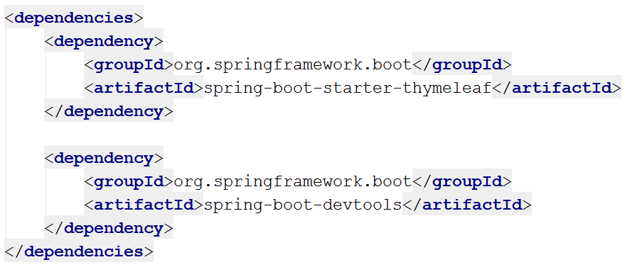

Now **rebuild** the project and **restart** the server. You will not need to do this more after changing the project. The Spring Boot server will restart automatically after a project change. Make sure to press **[Ctrl+F9] in IntelliJ IDEA** when you want to see the changes in the source code or view templates.

## Create the Site Layout (Header, Menu, Footer, CSS)

Now, let’s build the **site layout** (also known as master page template). The site layout includes the parts of the site, which should be **shared between all site pages**:

* **Head** section – holds the site <head> section with the CSS and scripts references.
* Site **header** section – holds the site header and top menu.
* Site **footer** section – holds the site footer area.

Create a new HTML file “layout.html” in src/main/resources/templates. It will hold the site layout:

|  |
| --- |
| src/main/resources/templates/**layout.html** |
| <!DOCTYPE **html**> <**html xmlns:th="http://www.thymeleaf.org"**>  <**head th:fragment="site-head"**>  <**meta charset="UTF-8"** />  <**link rel="stylesheet" href="../public/css/styles.css" th:href="@{/css/styles.css}"** />  <**link rel="icon" href="../public/img/favicon.ico" th:href="@{/img/favicon.ico}"** />  <**script src="../public/js/jquery-3.1.0.min.js"**  **th:src="@{/js/jquery-3.1.0.min.js}"**></**script**>  <**script src="../public/js/blog-scripts.js" th:src="@{/js/blog-scripts.js}"**></**script**>  <**meta th:include="this :: head" th:remove="tag"**/> </**head**>  <**body**>  <**header th:fragment="site-header"**>  <**a href="index.html" th:href="@{/}"**><**img**  **src="../public/img/site-logo.png" th:src="@{/img/site-logo.png}"** /></**a**>  <**a href="index.html" th:href="@{/}"**>Home</**a**>  <**a href="users/login.html" th:href="@{/users/login}"**>Login</**a**>  <**a href="users/register.html" th:href="@{/users/register}"**>Register</**a**>  <**a href="posts/index.html" th:href="@{/posts}"**>Posts</**a**>  <**a href="posts/create.html" th:href="@{/posts/create}"**>Create Post</**a**>  <**a href="users/index.html" th:href="@{/users}"**>Users</**a**>  <**div id="logged-in-info"**>  <**span**>Hello, <**b**>(user)</**b**></**span**>  <**form method="post" th:action="@{/users/logout}"**>  <**input type="submit" value="Logout"**/>  </**form**>  </**div**>  </**header**>   <**h1**>Welcome</**h1**>  <**p**>Welcome to the Spring MVC Blog.</**p**>   <**footer th:fragment="site-footer"**>  **&copy;** Spring MVC Blog System, 2016  </**footer**> </**body**>  </**html**> |

The above file “layout.html” holds several **Thymeleaf fragments** that will be included in all site pages:

* The “**site-head**” fragment holds the <head> section. It includes the site CSS, JavaScript code, etc. It appends to the page <head> section the <head> section of the invoking page, e.g. index.html.
* The “**site-header**” fragment holds the **site header**: site **logo** + top navigation **links** to the other site pages. It also holds the “**Logout**” form. The header now holds links to all pages, but once the login / logout functionality is implemented, it will **show / hide some of the links** for anonymous site **visitors** and for the **authenticated users**.
* The “**site-footer**” fragment is very simple. It holds some static text for the **site footer**.

**Note** that the links in the above code look like **duplicated**, because there are two attributes that specify the resource address: href="…" and th:href="…". This is because Thymeleaf uses [**natural templates**](https://en.wikipedia.org/wiki/Comparison_of_web_template_engines). “Natural templates” means that the template is a document as valid as the final result and the view engine syntax doesn't break the document's structure. The href value specifies the relative resource location **in the system** (provided by the Web site designer, e.g. “**../public/css/styles.css**”). The th:href value specifies the resource runtime **location at the Web server** (which is relative to the site root, e.g. “**/css/styles.css**”).

Once you have created the site layout template, it is time to modify the home view “index.html” to use this site layout by including its site-head, site-header and site-footer fragments using the Thymeleaf th:replace attributes as it is shown below:

|  |
| --- |
| src/main/resources/templates/**index.html** |
| <!DOCTYPE **html**> <**html xmlns:th="http://www.thymeleaf.org"**>  <**head th:replace="layout :: site-head"**>  <**title**>Welcome to Spring MVC Blog</**title**> </**head**>  <**body**>  <**header th:replace="layout :: site-header"** />   <**h1**>Welcome to Spring MVC</**h1**>  Now is: <**b th:text="${execInfo.now.time}"**>date and time</**b**>   <**footer th:replace="layout :: site-footer"** /> </**body**>  </**html**> |

The concept of “**natural templates**” is simple: if you **open directly** in a Web browser the above HTML files (by double-clicking on layout.html or index.html), without rendering them through the Thymeleaf view engine, their HTML content will be displayed correctly and will look meaningful.

Now **make the project** ([Ctrl+F9] in IntelliJ IDEA) and **refresh the browser** to see the changes:

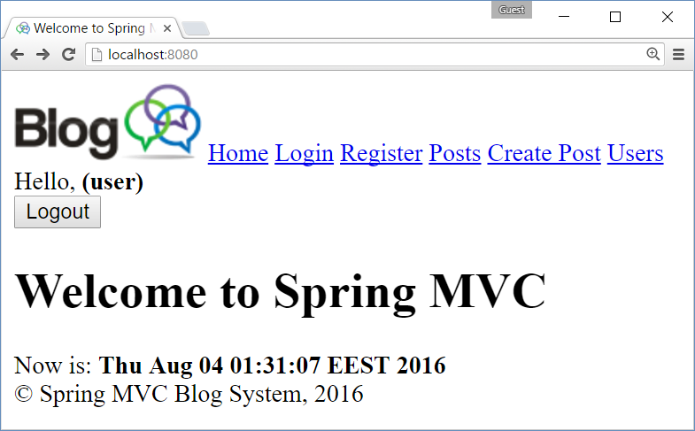

The site **header** and **footer** should be shown correctly but look a little bit ugly, because **there is no CSS** styles. The site browser icon (at the top left corner) is also change (by the favico.ico file in the site header).

## Add CSS Styles for the Site Layout

Let’s style the header, footer and the main page content. Add these **style definitions** in the site **CSS** file:

|  |
| --- |
| src/main/resources/public/css/**styles.css** |
| **body**>**header** {  **background**: **#eee**;  **padding**: 5**px**; }  **body**>**header**>**a**>**img**, **body**>**header a** {  **display**: **inline-block**;  **vertical-align**: **middle**;  **padding**: 0**px** 5**px**;  **font-size**: 1.2**em**; }  **body**>**footer** {  **background**: **#eee**;  **padding**: 5**px**;  **margin**: 10**px** 0;  **text-align**: **center**; }  **#logged-in-info** {  **float**: **right**;  **margin-top**: 18**px**; }  **#logged-in-info form** {  **display**: **inline-block**;  **margin-right**: 10**px**; } |

Now **save** the changes, **make** the project and **refresh** the Web browser to see how the site looks after the styling:

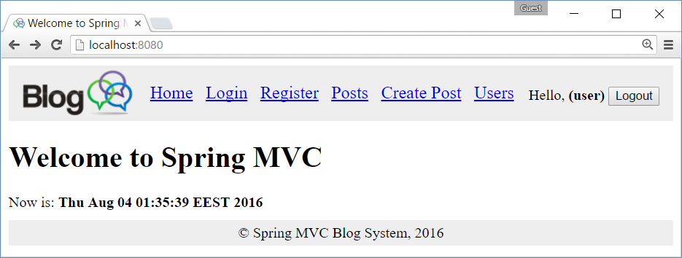

Congratulations, you have successfully created the **site layout** (the shared head, header, footer and CSS).

# Part II: Build the Application UI (Spring MVC)

In this section we shall build the application **user interface (UI)** without connecting it to the database. We shall build **controllers** and **views** to implement the user interface of the project. Instead of connecting to the database, we shall use stub **service** implementations that provide **sample data** for visualization in the view templates.

## Create Entity Classes: “User” and “Post”

In order to create the controllers and views of the Blog system, we will need the **entity classes** (data models) to hold **users** and **posts**. Let’s create these classes.

First, create a class User in the package blog.models to hold information about blog users. **Users** have id, username, passwordHash (encrypted password), fullName and a **set of posts**:

|  |
| --- |
| src/main/java/blog/models/**User.java** |
| **package** blog.models;  **import** java.util.HashSet; **import** java.util.Set;  **public class** User {  **private** Long **id**;  **private** String **username**;  **private** String **passwordHash**;  **private** String **fullName**;  **private** Set<Post> **posts** = **new** HashSet<>(); } |

Now generate **getters and setters** (for all fields), **constructors** (empty and by id + username + fullName) and toString() method (don’t print the set of posts in the toString() to avoid endless recursion) in the User class:

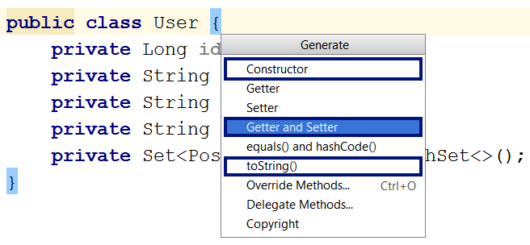

The **generated code** might look as follows:

|  |
| --- |
| src/main/java/blog/models/**User.java** |
| **public class** User {  **…**  **public** Long getId() { **return id**; }  **public void** setId(Long id) { **this**.**id** = id; }  **public** String getUsername() { **return username**; }  **public void** setUsername(String username) { **this**.**username** = username; }  **public** String getPasswordHash() { **return passwordHash**; }  **public void** setPasswordHash(String passHash) { **this**.**passwordHash** = passHash; }  **public** String getFullName() { **return fullName**; }  **public void** setFullName(String fullName) { **this**.**fullName** = fullName; }  **public** Set<Post> getPosts() { **return posts**; }  **public void** setPosts(Set<Post> posts) { **this**.**posts** = posts; }  **public** User() { }  **public** User(Long id, String username, String fullName) {  **this**.**id** = id;  **this**.**username** = username;  **this**.**fullName** = fullName;  }  @Override  **public** String toString() {  **return "User{"** + **"id="** + **id** + **", username='"** + **username** + **'\''** +  **", passwordHash='"** + **passwordHash** + **'\''** +  **", fullName='"** + **fullName** + **'\''** + **'}'**;  } } |

Next, create a class Post in the package blog.models to hold information about blog posts. **Posts** have id, title, body, date of publishing (defaults to the current date and time) and an author (which is User):

|  |
| --- |
| src/main/java/blog/models/**Post.java** |
| **package** blog.models;  **import** java.util.Date;  **public class** Post {  **private** Long **id**;  **private** String **title**;  **private** String **body**;  **private** User **author**;  **private** Date **date** = **new** Date(); } |

Generate **getters and setters** (for all fields), **empty constructor**, **constructors** by id + title + body + author and toString() method for the Post class. Your code might look like the shown below (it is intentionally shown as image to avoid copy / paste):

|  |
| --- |
| src/main/java/blog/models/**Post.java** |
|  |

## Create Service Interface “PostService”

In Spring MVC uses a layered architecture: **controllers** 🡪 **services** 🡪 **repositories** 🡪 **models** 🡪 **database**.

* **Controllers** – hold the **presentation (UI) logic** – process user request (GET / POST / other), prepare data for the view and render the view (or redirect to another URL). Example: prepare and show the home page.
* **Services** – hold the **business logic**. Often just call some repository method. Example: create new post / show a post for deleting / delete post. Services may have several **implementations**: DB based or stub based.
* **Repositories** – implement the **database CRUD operations** (create / read / edit / delete) in the database for certain entity class (model). Examples: find post by id / delete post by id. Often provided by the framework (not written by hand).
* **Models (entity classes)** – holds the data about the **application data**. Examples: user, post, tag, …

Now, create the **service interface** that will provide the business logic for working with posts in the blog system:

|  |
| --- |
| src/main/java/blog/services/**PostService.java** |
| **package** blog.services;  **import** blog.models.Post;  **import** java.util.List;  **public interface** PostService {  List<Post> findAll();  List<Post> findLatest5();  Post findById(Long id);  Post create(Post post);  Post edit(Post post);  **void** deleteById(Long id); } |

The PostService interface provides all the functionality about posts that is needed for the blog system.

## Create Stub Service Implementation “PostServiceStubImpl”

To **reduce the complexity**, the blog application will be created **step by step**. First, the blog will be implemented to work **without a database**: users and posts will be stored in the server memory. Later, the database persistence will be implemented to replace the in-memory object storing.

Let’s implement a **stub** (sample data, stored in the memory) for the PostService. It will be a Java class called PostServiceStubImpl. It will hold the **posts** in a List<Post> collection and the service methods will be easy to be implemented:

|  |
| --- |
| src/main/java/blog/services/**PostServiceStubImpl.java** |
| **package** blog.services;  **import** blog.models.Post; **import** blog.models.User; **import** org.springframework.stereotype.Service;  **import** java.util.*; **import** java.util.stream.Collectors;  @Service **public class** PostServiceStubImpl **implements** PostService {  **private** List<Post> **posts** = **new** ArrayList<Post>() {{  add(**new** Post(1L, **"First Post"**, **"<p>Line #1.</p><p>Line #2</p>"**, **null**));  add(**new** Post(2L, **"Second Post"**,  **"Second post content:<ul><li>line 1</li><li>line 2</li></p>"**,  **new** User(10L, **"pesho10"**, **"Peter Ivanov"**)));  add(**new** Post(3L, **"Post #3"**, **"<p>The post number 3 nice</p>"**,  **new** User(10L, **"merry"**, **null**)));  add(**new** Post(4L, **"Forth Post"**, **"<p>Not interesting post</p>"**, **null**));  add(**new** Post(5L, **"Post Number 5"**, **"<p>Just posting</p>"**, **null**));  add(**new** Post(6L, **"Sixth Post"**, **"<p>Another interesting post</p>"**, **null**));  }};   @Override  **public** List<Post> findAll() {  **return this**.**posts**;  }   @Override  **public** List<Post> findLatest5() {  **return this**.**posts**.stream()  .sorted((a, b) -> b.getDate().compareTo(a.getDate()))  .limit(5)  .collect(Collectors.*toList*());  }   @Override  **public** Post findById(Long id) {  **return this**.**posts**.stream()  .filter(p -> Objects.*equals*(p.getId(), id))  .findFirst()  .orElse(**null**);  }   @Override  **public** Post create(Post post) {  post.setId(**this**.**posts**.stream().mapToLong(  p -> p.getId()).max().getAsLong() + 1);  **this**.**posts**.add(post);  **return** post;  }   @Override  **public** Post edit(Post post) {  **for** (**int** i = 0; i < **this**.**posts**.size(); i++) {  **if** (Objects.*equals*(**this**.**posts**.get(i).getId(), post.getId())) {  **this**.**posts**.set(i, post);  **return** post;  }  }  **throw new** RuntimeException(**"Post not found: "** + post.getId());  }   @Override  **public void** deleteById(Long id) {  **for** (**int** i = 0; i < **this**.**posts**.size(); i++) {  **if** (Objects.*equals*(**this**.**posts**.get(i).getId(), id)) {  **this**.**posts**.remove(i);  **return**;  }  }  **throw new** RuntimeException(**"Post not found: "** + id);  } } |

The above service implementation is just **for testing**. It will allow us to develop the application frond-end UI (controllers and views) without carrying about the complexity of the database access. It will also make the application services testable without the need of database. Let’s update the home page controller.

**Note**: the annotation **@Service** for the service implementation class is important here. It tells the Spring Framework that this class will be used by the application controllers as a **service** and Spring Framework will **automatically instantiate** and **inject** it in the controllers (through the **@Autowired** annotation).

## Invoke the “PostService” from the Home Page Controller

Now, let’s **update the home page controller** to use the PostService and its testing stub implementation PostServiceStubImpl. Now the HomeController.index() method should **prepare** for the view the **latest 3 blog posts** (to be shown at the home page) + **the latest 5 blog posts** (to be shown at the sidebar).

|  |
| --- |
| src/main/java/blog/controllers/**HomeController.java** |
| @Controller **public class** HomeController {  @Autowired  **private** PostService **postService**;   @RequestMapping(**"/"**)  **public** String index(Model model) {  List<Post> latest5Posts = **postService**.findLatest5();  model.addAttribute(**"latest5posts"**, latest5Posts);  List<Post> latest3Posts = latest5Posts.stream()  .limit(3).collect(Collectors.*toList*());  model.addAttribute(**"latest3posts"**, latest3Posts);  **return "index"**;  } } |

Note the **@Autowired** annotation before the postService field. This is **the** **“magic” of Spring Framework**. It automatically **injects** the correct implementation for your services at the places where they are needed. Developers just type **“@Autowired**”. Spring scans the project and finds all classes that implement the service interface. If only one such class is found, it is instantiated and its instance is **auto-wired (injected)** in the field or method parameter where it is requested.

The above controller action puts in the **view model** the latest 5 posts as object named “latest5posts” and the latest 3 posts as object named “latest3posts” to be shown at the home page by the view. Now it is time to write the **home page view** to process these posts.

## Implement “List Latest 3 Posts” at the Home Page Main Area

Let’s modify the **home page view** to display the latest 3 posts:

|  |
| --- |
| src/main/resources/templates/**index.html** |
| <!DOCTYPE **html**> <**html xmlns:th="http://www.thymeleaf.org"**>  <**head th:replace="layout :: site-head"**>  <**title**>Spring MVC Blog</**title**> </**head**>  <**body**>  <**header th:replace="layout :: site-header"** />   <**main id="posts"**>  <**article th:each="p : ${latest3posts}"**>  <**h2 class="title" th:text="${p.title}"**>Post Title</**h2**>  <**div class="date"**>  <**i**>Posted on</**i**>  <**span th:text="${#dates.format(p.date, 'dd-MMM-yyyy')}"**>22-May-2016</**span**>  <**span th:if="${p.author}" th:remove="tag"**>  <**i**>by</**i**> <**span th:text="${p.author.fullName != null ?  p.author.fullName : p.author.username}"**>Svetlin Nakov</**span**>  </**span**>  </**div**>  <**p class="content" th:utext="${p.body}"**>Post content</**p**>  </**article**>  </**main**>   <**footer th:replace="layout :: site-footer"** /> </**body**>  </**html**> |

The view iterates over the “latest3posts” collection and for each post in it shows the post details: **title**, **date** (in format dd-MMM-yyyy, e.g. 22-May-2016), **author** (when available, print its **full name** or just its **username** when the full name is missing) and post **body**.

**Make the project** and **open the home page** from your Web browser. It should look like this:

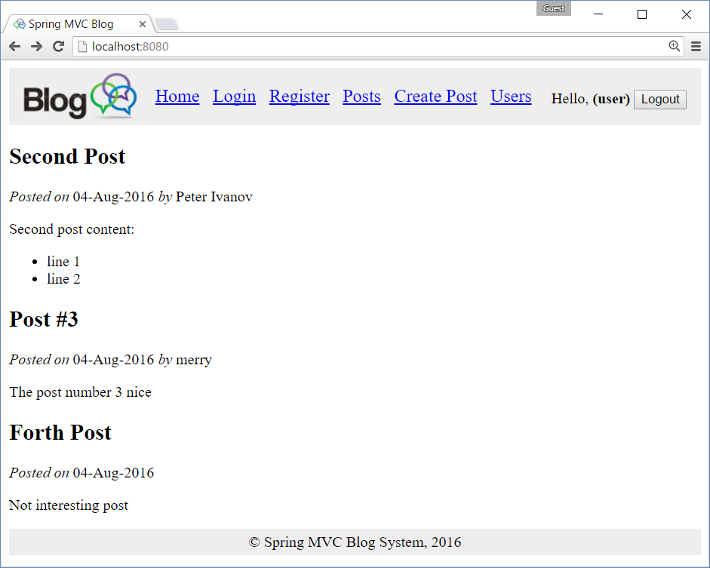

## Implement the “List latest 5 Posts” at the Home Page Sidebar

Now implement the **sidebar at the home page** that holds the titles of the last 5 posts in hyperlinks to these posts. Add the following code just **after the header** in the index.html home page template:

|  |
| --- |
| src/main/resources/templates/**index.html** |
| <**aside**>  <**h2**>Recent Posts</**h2**>  <**a href="#" th:each="p : ${latest5posts}" th:text="${p.title}"**  **th:href="@{/posts/view/{id}/(id=${p.id})}"**>Work Begins on HTML5.1</**a**> </**aside**> |

Now **test the application**. It should display **5 links at the home page**, just after the page header:

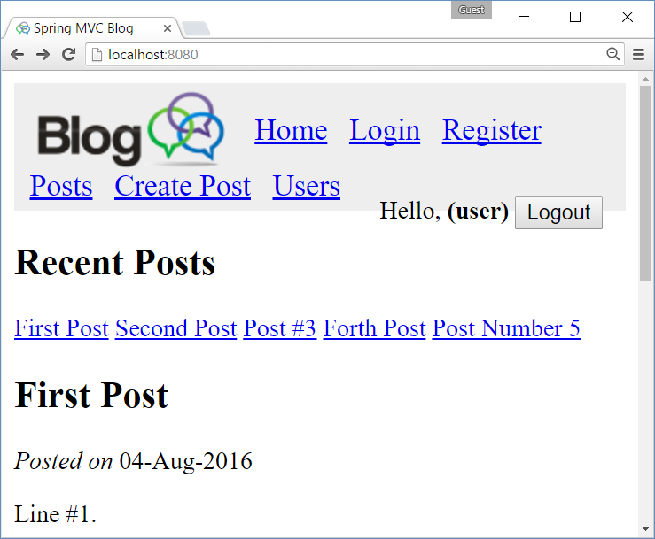

Now add some **CSS styles** to make these links display correctly at the **sidebar on the right** sideof the home page. Append the following code in your styles.css file:

|  |
| --- |
| src/main/resources/public/css/**styles.css** |
| **body**>**aside** {  **float**: **right**;  **width**: 200**px**;  **background**: **#CCC**;  **padding**: 15**px**;  **margin-left**: 20**px**;  **margin-top**: 10**px**; }  **body**>**aside h2** {  **margin**: 5**px** 0**px** 15**px** 0**px**; }  **body**>**aside a** {  **display**: **block**;  **margin**: 5**px** 0**px**;  **text-decoration**: **none**; }  **body**>**main**:**after** {  **content**: **''**;  **display**: **block**;  **clear**: **both**; } |

Now the sidebar looks better:

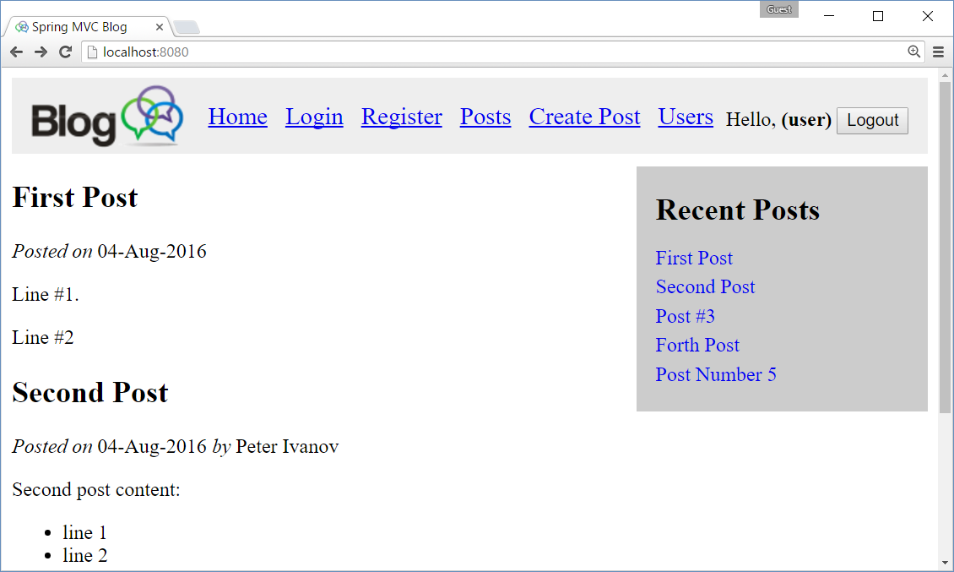

## Create the “Post Details” Page

Now create the **“Post Details” page**, which will display a single post by **id**. It will be invoked when user clicks on the links in the Sidebar. It will be mapped to URL /posts/view/{id}/, e.g. <http://localhost:8080/posts/view/3/>.

### Create “Post Details” Action in PostsController

Create the PostsController and its action view(id):

|  |
| --- |
| src/main/java/blog/controllers/**PostsController.java** |
| @Controller **public class** PostsController {  @Autowired  **private** PostService **postService**;   @RequestMapping(**"/posts/view/{id}"**)  **public** String view(@PathVariable(**"id"**) Long id, Model model) {  Post post = **postService**.findById(id);  model.addAttribute(**"post"**, post);  **return "posts/view"**;  } } |

The PostsController works like the HomeController. It handles URLs like /posts/view/{id}/ and finds the requested post using the **@Autowired** implementation of the PostService and renders the view “posts/view”, which corresponds to the file “view.html” in directory src/main/resources/templates/posts. For cleaner organization, all post-related views are placed in a subdirectory “posts” under “templates”.

### Create “Post Details” View

Create the posts/view.html template (view) to display the post loaded by the PostsController:

|  |
| --- |
| src/main/resources/templates/**posts/view.html** |
| <!DOCTYPE **html**> <**html xmlns:th="http://www.thymeleaf.org"**>  <**head th:replace="layout :: site-head"**>  <**title th:text="${post.title}"**>View Post</**title**> </**head**>  <**body**>  <**header th:replace="layout :: site-header"** />   <**main id="posts"**>  <**article**>  <**h2 class="title" th:text="${post.title}"**>Post Title</**h2**>  <**div class="date"**>  <**i**>Posted on</**i**>  <**span th:text="${#dates.format(post.date, 'dd-MMM-yyyy')}"**>22-May-2016</**span**>  <**span th:if="${post.author}" th:remove="tag"**>  <**i**>by</**i**> <**span th:text="${post.author.fullName != null ?  post.author.fullName : post.author.username}"**>Svetlin Nakov</**span**>  </**span**>  </**div**>  <**p class="content" th:utext="${post.body}"**>Post content</**p**>  </**article**>  </**main**>   <**footer th:replace="layout :: site-footer"** /> </**body**>  </**html**> |

The view “posts/view.html” works exactly like the home view “index.html”. It shows the post details: **title**, formatted **date**, **author** (when available, print its **full name** or **username** when the full name is missing) and post **body**. Like any other view, it re-uses the “head”, “site-header” and “site-footer” fragments from “layout.html”. Additionally, it changes the **page title** to hold the **post title**.

### Test the “Post Details” View

**Run the project** (just recompile it and refresh the browser) to see how the new page works:

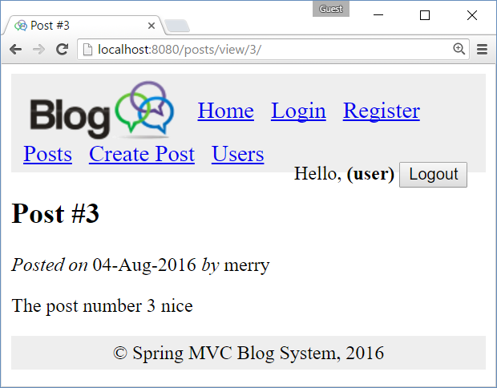

### Test the “Post Details” View for Invalid Post

Looks good, but what will happen, if a wrong post is open, e.g. /posts/view/150? Let’s see:

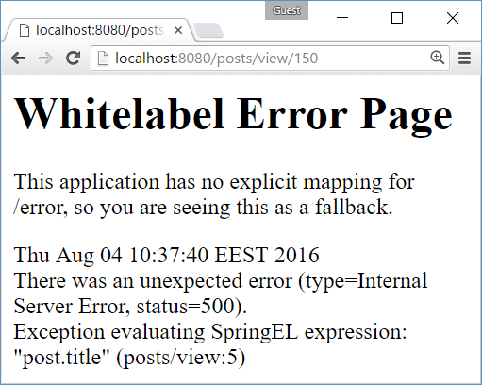

It would be better if the application says something like “Sorry, the post #150 is not found” in a good-looking form. You might change the error page following the Spring Boot documentation: <http://docs.spring.io/spring-boot/docs/current/reference/htmlsingle/#boot-features-error-handling-custom-error-pages>.

## Implement Notifications System

Let’s implement a “**notification system**” that allows us to display **success** / **error** **messages**, like these:





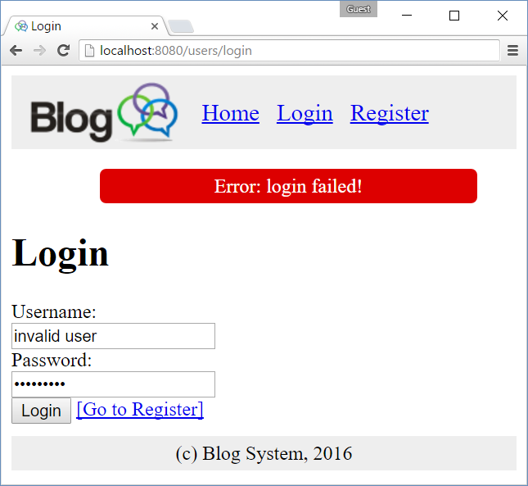

A good approach is to create a NotificationService, which will encapsulate the logic related to adding and storing the info / error messages + add some code in the site **layout template** to show the messages (when available). Let’s create a **notification service**, **implementation** of this service and **notifications view template**.

### Notification Service Interface

Create a new Java interface called “NotificationService.java” in src/main/java/blog/services:

|  |
| --- |
| src/main/java/blog/services/**NotificationService.java** |
| **package** blog.services;  **public interface** NotificationService {  **void** addInfoMessage(String msg);  **void** addErrorMessage(String msg); } |

This service interface provides methods for adding **error** and **information messages** for displaying later in the view.

### Notification Service Implementation

Implement the NotificationService interface in a new Java class called NotificationServiceImpl. It stores the info and error messages in a List<NotificationMessage> in the HTTP session. The **HTTP session** is a special place where you can **store objects** (key 🡪 value) and they persist **for long time**. HTTP session objects survive request redirections and may be accessed long time later after they are created. The notification messages will be displayed later in the **site header** (in layout.html). To implement the notification service, just create the class:

|  |
| --- |
| src/main/java/blog/services/**NotificationServiceImpl.java** |
| **package** blog.services;  **import** org.springframework.beans.factory.annotation.Autowired; **import** org.springframework.stereotype.Service;  **import** javax.servlet.http.HttpSession; **import** java.util.ArrayList; **import** java.util.List;  @Service() **public class** NotificationServiceImpl **implements** NotificationService {   **public static final** String ***NOTIFY_MSG_SESSION_KEY*** = **"siteNotificationMessages"**;   @Autowired  **private** HttpSession **httpSession**;   @Override  **public void** addInfoMessage(String msg) {  addNotificationMessage(NotificationMessageType.***INFO***, msg);  }   @Override  **public void** addErrorMessage(String msg) {  addNotificationMessage(NotificationMessageType.***ERROR***, msg);  }   **private void** addNotificationMessage(NotificationMessageType type, String msg) {  List<NotificationMessage> notifyMessages = (List<NotificationMessage>)  **httpSession**.getAttribute(***NOTIFY_MSG_SESSION_KEY***);  **if** (notifyMessages == **null**) {  notifyMessages = **new** ArrayList<NotificationMessage>();  }  notifyMessages.add(**new** NotificationMessage(type, msg));  **httpSession**.setAttribute(***NOTIFY_MSG_SESSION_KEY***, notifyMessages);  }   **public enum** NotificationMessageType {  ***INFO***,  ***ERROR*** }   **public class** NotificationMessage {  NotificationMessageType **type**;  String **text**;   **public** NotificationMessage(NotificationMessageType type, String text) {  **this**.**type** = type;  **this**.**text** = text;  }   **public** NotificationMessageType getType() {  **return type**;  }   **public** String getText() {  **return text**;  }  } } |

### Modify the Layout View Template to Show Notifications

Now the messages are available in the **HTTP session**. It is time to **display them** after the site header and remove them from the session (after they have been successfully shown to the user). **Replace** the “site-header” fragment in the layout view “layout.html” with the following:

|  |
| --- |
| src/main/resources/templates/**layout.html** |
| …  <**header th:fragment="site-header" th:remove="tag"**>  <**header**>  <**a href="index.html" th:href="@{/}"**><**img  src="../public/img/site-logo.png" th:src="@{/img/site-logo.png}"** /></**a**>  <**a href="index.html" th:href="@{/}"**>Home</**a**>  <**a href="users/login.html" th:href="@{/users/login}"**>Login</**a**>  <**a href="users/register.html" th:href="@{/users/register}"**>Register</**a**>  <**a href="posts/index.html" th:href="@{/posts}"**>Posts</**a**>  <**a href="posts/create.html" th:href="@{/posts/create}"**>Create Post</**a**>  <**a href="users/index.html" th:href="@{/users}"**>Users</**a**>  <**div id="logged-in-info"**>  <**span**>Hello, <**b**>(user)</**b**></**span**>  <**form method="post" th:action="@{/users/logout}"**>  <**input type="submit" value="Logout"**/>  </**form**>  </**div**>  </**header**>   <**ul id="messages" th:with="notifyMessages=${session[T(blog.services  .NotificationServiceImpl).NOTIFY_MSG_SESSION_KEY]}"**>  <**li th:each="msg : ${notifyMessages}"  th:text="${msg.text}"  th:class="${#strings.toLowerCase(msg.type)}"**>  </**li**>  <**span th:if="${notifyMessages}" th:remove="all" th:text="${session.remove(**  **T(blog.services.NotificationServiceImpl).NOTIFY_MSG_SESSION_KEY)}"**></**span**>  </**ul**> </**header**>  … |

The above code **first replaces the site header** with two elements:

* The original <header> element which holds the site logo and top navigation.
* A new element <ul id="messages"> to hold the notification messages

The code to show the notification messages is complex to be explained, but in brief: it iterates over the list of notification messages, **displays each message** in a <li> and finally **removes all messages** from the HTTP session.

### Modify the PostsController to Add Error Messages

Now add an error message notification in the PostsController, when an **invalid post** id is requested:

|  |
| --- |
| src/main/java/blog/controllers/**PostsController.java** |
| @Controller **public class** PostsController {  @Autowired  **private** PostService **postService**;   @Autowired  **private** NotificationService **notifyService**;   @RequestMapping(**"/posts/view/{id}"**)  **public** String view(@PathVariable(**"id"**) Long id, Model model) {  Post post = **postService**.findById(id);  **if** (post == **null**) {  **notifyService**.addErrorMessage(**"Cannot find post #"** + id);  **return "redirect:/"**;  }  model.addAttribute(**"post"**, post);  **return "posts/view"**;  } } |

The above code first **injects the notification service** by “**@Autowired**” annotation. It adds a **check** in the view(id) action and in case of invalid post id, it **adds an error message** though the notification service and **redirects to the home page**, where this message well be shown.

### Add CSS Styles for the Notification Messages

|  |
| --- |
| src/main/resources/public/css/**styles.css** |
| **ul#messages li** {  **display**: **block**;  **width**: 80%;  **margin**: 5**px auto**;  **text-align**: **center**;  **padding**: 5**px**;  **border-radius**: 5**px**; }  **ul#messages li**.**info** {  **background**: **#7f7**; }  **ul#messages li**.**error** {  **background**: **#d00**;  **color**: **white**; } |

### Test the Notification Messages

To test the notification messages, open an invalid post, e.g. <http://localhost:8080/posts/view/12345>. The result should be like this:

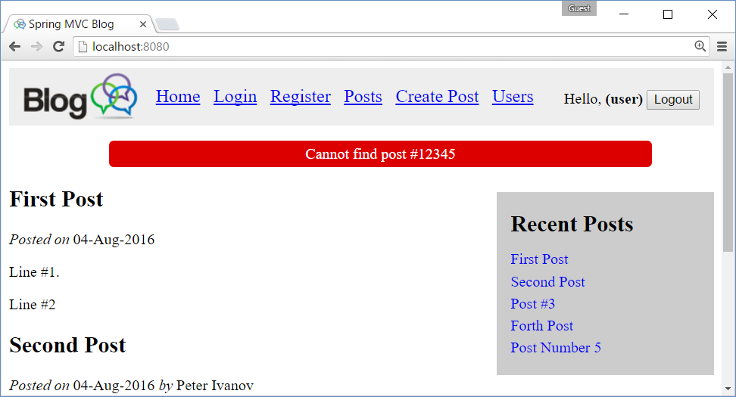

### Add JavaScript to Animate the Notification Messages

Now, let’s make the notification messages more fancy. Add **JavaScript code** that will hide automatically all notification messages after 3 seconds and will **hide all notification messages on mouse click**. Add the following code in the main file, holding the site JavaScript code “blog-scripts.js”:

|  |
| --- |
| src/main/resources/public/js/**blog-scripts.js** |
| **$**(**function**() {  **$**(**'#messages li'**).click(**function**() {  **$**(**this**).**fadeOut**();  });  setTimeout(**function**() {  **$**(**'#messages li.info'**).**fadeOut**();  }, 3000); }); |

The above **JS code** is loaded by the layout template (in the “site-head” fragment), just after the **jQuery** library and the function in it is executed when the page is completely loaded. The code finds all <li class="message"> elements with jQuery and attaches **event handlers** to hide them (with pleasant fade-out effect) on mouse click or at 3000 milliseconds timeout (for .info messages).

## Create the “Login” Page

**Forms** are a bit more complicated. Let’s create the **login page** and its functionality.

### Create LoginForm Model Class

First, create the **login form model**. It holds the validation rules for the form fields:

|  |
| --- |
| src/main/java/blog/forms/**LoginForm.java** |
| **package** blog.forms;  **import** javax.validation.constraints.NotNull; **import** javax.validation.constraints.Size;  **public class** LoginForm {  @Size(min=2, max=30, message = **"Username size should be in the range [2...30]"**)  **private** String **username**;   @NotNull  @Size(min=1, max=50)  **private** String **password**;   **public** String getUsername() {  **return username**;  }   **public void** setUsername(String username) {  **this**.**username** = username;  }   **public** String getPassword() {  **return password**;  }   **public void** setPassword(String password) {  **this**.**password** = password;  } } |

### Create UserService

Next, create the **user service interface** that implements the login **authentication functionality**:

|  |
| --- |
| src/main/java/blog/services/**UserService.java** |
| **package** blog.services;  **public interface** UserService {  **boolean** authenticate(String username, String password); } |

### Create UserServiceStubImpl

Next, create the **user service stub implementation** (we shall have real implementation later):

|  |
| --- |
| src/main/java/blog/services/**UserServiceStubImpl.java** |
| **package** blog.services;  **import** org.springframework.stereotype.Service;  **import** java.util.Objects;  @Service **public class** UserServiceStubImpl **implements** UserService {  @Override  **public boolean** authenticate(String username, String password) {  *// Provide a sample password check: username == password* **return** Objects.*equals*(username, password);  } } |

### Create the LoginController

Next, create the **login controller**:

|  |
| --- |
| src/main/java/blog/controllers/**LoginController.java** |
| **package** blog.controllers;  **import** blog.forms.LoginForm; **import** blog.services.NotificationService; **import** blog.services.UserService; **import** org.springframework.beans.factory.annotation.Autowired; **import** org.springframework.stereotype.Controller; **import** org.springframework.validation.BindingResult; **import** org.springframework.web.bind.annotation.RequestMapping; **import** org.springframework.web.bind.annotation.RequestMethod;  **import** javax.validation.Valid;  @Controller **public class** LoginController {   @Autowired  **private** UserService **userService**;   @Autowired  **private** NotificationService **notifyService**;   @RequestMapping(**"/users/login"**)  **public** String login(LoginForm loginForm) {  **return "users/login"**;  }   @RequestMapping(value = **"/users/login"**, method = RequestMethod.***POST***)  **public** String loginPage(@Valid LoginForm loginForm, BindingResult bindingResult) {  **if** (bindingResult.hasErrors()) {  **notifyService**.addErrorMessage(**"Please fill the form correctly!"**);  **return "users/login"**;  }   **if** (!**userService**.authenticate(  loginForm.getUsername(), loginForm.getPassword())) {  **notifyService**.addErrorMessage(**"Invalid login!"**);  **return "users/login"**;  }   **notifyService**.addInfoMessage(**"Login successful"**);  **return "redirect:/"**;  } } |

### Create the Login View

Finally, create the **login view**:

|  |
| --- |
| src/main/resources/templates/users/**login.html** |
| <!DOCTYPE **html**> <**html xmlns:th="http://www.thymeleaf.org"**>  <**head th:replace="layout :: site-head"**>  <**title**>Login</**title**> </**head**>  <**body**>  <**header th:replace="layout :: site-header"** />   <**h1**>Login in the Blog</**h1**>   <**form method="post" th:object="${loginForm}"**>  <**div**><**label for="username"**>Username:</**label**></**div**>  <**input id="username" type="text" name="username" th:value="*{username}"** />  <**span class="formError" th:if="${#fields.hasErrors('username')}"  th:errors="*{username}"**>Invalid username</**span**>   <**div**><**label for="password" th:value="*{username}"**>Password:</**label**></**div**>  <**input id="password" type="password" name="password" th:value="*{password}"** />  <**span class="formError" th:if="${#fields.hasErrors('password')}"  th:errors="*{password}"**>Invalid password</**span**>   <**div**><**input type="submit" value="Login"**/>  <**a href="register.html" th:href="@{/users/register}"**>[Go to Register]</**a**></**div**>  </**form**>   <**footer th:replace="layout :: site-footer"** /> </**body**>  </**html**> |

### Add CSS for the Form Validation

Add some **CSS** for the form validation:

|  |
| --- |
| src/main/resources/public/css/**styles.css** |
| .**formError** {  **color**: **red**;  **font-style**: **italic**; } |

### Test the Login Form Functionality

Now **run** the login form and **test** it:

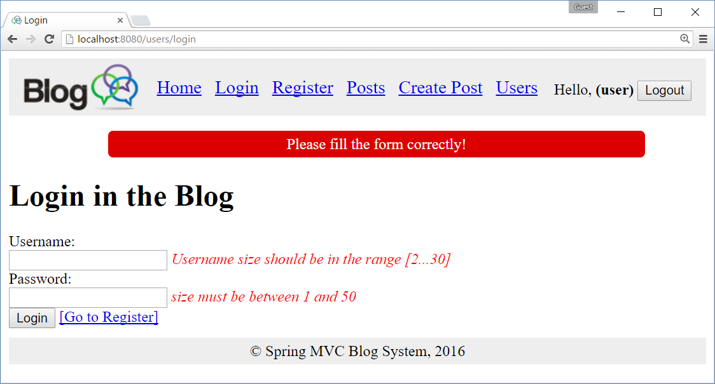

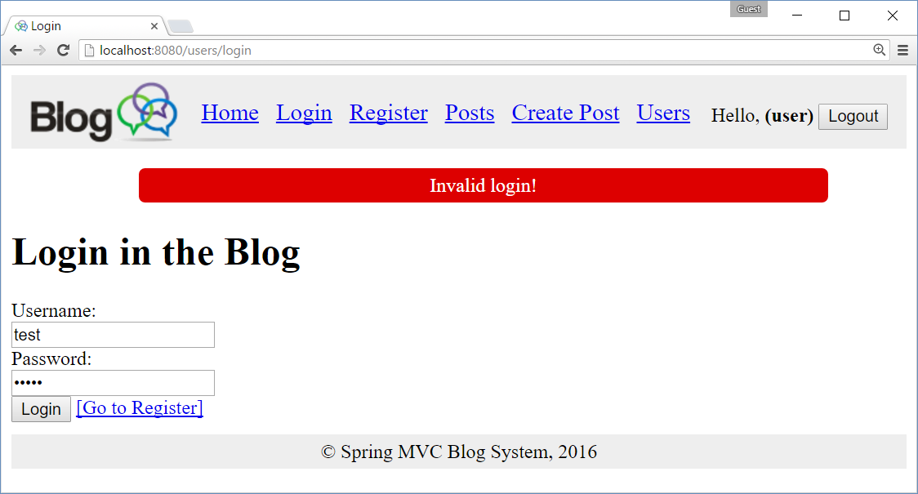

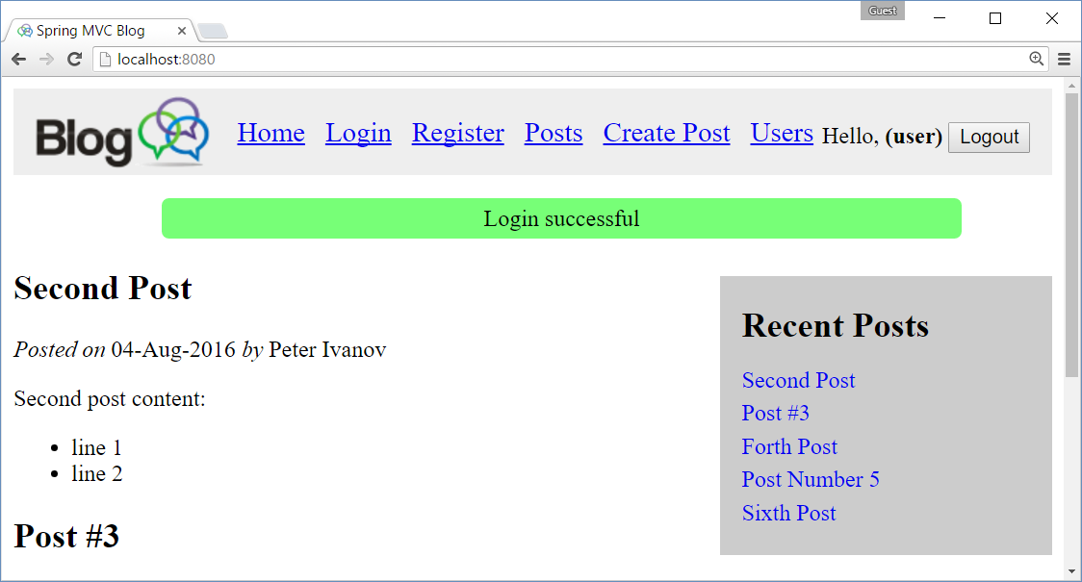

## Create the “User Registration” Page

Create the page like the previous one. It is very similar.

## Create the “List Posts” Page

TODO

## Create the “Create New Post” Page

TODO

## Create the “Delete Post” Page

TODO

## Create the “Edit Existing Post” Page

TODO

## Create the “List Users” Page

TODO

# Part III: Connect the Application to the DB (Spring Data JPA)

In this section we shall connect the application to the **database** and implement data access logic with **Spring Data JPA**, **JPA**, **Hibernate** and **MySQL**.

## Add Spring Data Maven Dependencies

Add **Spring Data JPA** and **MySQL** dependencies in the **Maven** project settings:

|  |
| --- |
| **pom.xml** |
| <**dependency**>  <**groupId**>org.springframework.data</**groupId**>  <**artifactId**>spring-data-jpa</**artifactId**> </**dependency**>  <**dependency**>  <**groupId**>org.springframework.boot</**groupId**>  <**artifactId**>spring-boot-starter-data-jpa</**artifactId**> </**dependency**>  <**dependency**>  <**groupId**>mysql</**groupId**>  <**artifactId**>mysql-connector-java</**artifactId**>  <**version**>6.0.3</**version**> </**dependency**> |

## Define MySQL Connection Settings (application.properties)

Define the JPA settings to connect to your MySQL database. Ensure your MySQL server is running and the database “blog_db” exists inside it. Use the following database configuration settings:

|  |
| --- |
| src/main/resources/**application.properties** |
| **spring.thymeleaf.cache** = **false  spring.datasource.driver-class-name** = **com.mysql.cj.jdbc.Driver spring.datasource.url** = **jdbc:mysql://localhost/blog_db?characterEncoding=utf8 spring.datasource.username** = **root spring.datasource.password** =  *# Configure Hibernate DDL mode: create / update* **spring.jpa.properties.hibernate.hbm2ddl.auto** = **create** *# Disable the default loggers #logging.level.org = WARN #logging.level.blog = WARN  ### Show SQL executed with parameter bindings #logging.level.org.hibernate.SQL = DEBUG #logging.level.org.hibernate.type.descriptor = TRACE #spring.jpa.properties.hibernate.format_sql = TRUE* |

## Annotate the Entity Classes: User and Post

Put **JPA annotations** (table and column mappings + relationship mappings) to the entity classes in order to make then ready for **persistence** in the database through the **JPA** / Hibernate technology. Start with the User class:

|  |
| --- |
| src/main/java/blog/models/**User.java** |
| **package** blog.models;  **import** javax.persistence.*; **import** java.util.HashSet; **import** java.util.Set;  @Entity @Table(name = **"users"**) **public class** User {  @Id  @GeneratedValue(strategy = GenerationType.***IDENTITY***)  **private** Long **id**;   @Column(nullable = **false**, length = 30, unique = **true**)  **private** String **username**;   @Column(length = 60)  **private** String **passwordHash**;   @Column(length = 100)  **private** String **fullName**;   @OneToMany(mappedBy = **"author"**)  **private** Set<Post> **posts** = **new** HashSet<Post>();   **public** Long getId() {  **return id**;  }   **public void** setId(Long id) {  **this**.**id** = id;  }   **public** String getUsername() {  **return username**;  }   **public void** setUsername(String username) {  **this**.**username** = username;  }   **public** String getPasswordHash() {  **return passwordHash**;  }   **public void** setPasswordHash(String passwordHash) {  **this**.**passwordHash** = passwordHash;  }   **public** String getFullName() {  **return fullName**;  }   **public void** setFullName(String fullName) {  **this**.**fullName** = fullName;  }   **public** Set<Post> getPosts() {  **return posts**;  }   **public void** setPosts(Set<Post> posts) {  **this**.**posts** = posts;  }   **public** User() {  }   **public** User(String username, String fullName) {  **this**.**username** = username;  **this**.**fullName** = fullName;  }   **public** User(Long id, String username, String fullName) {  **this**.**id** = id;  **this**.**username** = username;  **this**.**fullName** = fullName;  }   @Override  **public** String toString() {  **return "User{"** +  **"id="** + **id** +  **", username='"** + **username** + **'\''** +  **", passwordHash='"** + **passwordHash** + **'\''** +  **", fullName='"** + **fullName** + **'\''** +  **'}'**;  } } |

Annotate in the same way the Post class:

|  |
| --- |
| src/main/java/blog/models/**Post.java** |
| **package** blog.models;  **import** javax.persistence.*; **import** java.util.Date;  @Entity @Table(name = **"posts"**) **public class** Post {  @Id  @GeneratedValue(strategy = GenerationType.***IDENTITY***)  **private** Long **id**;   @Column(nullable = **false**, length = 300)  **private** String **title**;   @Lob @Column(nullable = **false**)  **private** String **body**;   @ManyToOne(optional = **false**, fetch = FetchType.***LAZY***)  **private** User **author**;   @Column(nullable = **false**)  **private** Date **date** = **new** Date();   **public** Long getId() {  **return id**;  }   **public void** setId(Long id) {  **this**.**id** = id;  }   **public** String getTitle() {  **return title**;  }   **public void** setTitle(String title) {  **this**.**title** = title;  }   **public** String getBody() {  **return body**;  }   **public void** setBody(String body) {  **this**.**body** = body;  }   **public** User getAuthor() {  **return author**;  }   **public void** setAuthor(User author) {  **this**.**author** = author;  }   **public** Date getDate() {  **return date**;  }   **public void** setDate(Date date) {  **this**.**date** = date;  }   **public** Post() {}   **public** Post(Long id, String title, String body, User author) {  **this**.**id** = id;  **this**.**title** = title;  **this**.**body** = body;  **this**.**author** = author;  }   @Override  **public** String toString() {  **return "Post{"** +  **"id="** + **id** +  **", title='"** + **title** + **'\''** +  **", body='"** + **body** + **'\''** +  **", author="** + **author** +  **", date="** + **date** +  **'}'**;  } } |

## Create UserRepository and PostRepository (Spring Data JPA)

Create the interface UserRepository. Note that you **will not provide any implementation for it**. Spring Data JPA will implement it for you. This is part of **the “magic”** behind the “**Spring Data**” framework:

|  |
| --- |
| src/main/java/blog/repositories/**UserReposiory.java** |
| **package** blog.repositories;  **import** blog.models.User; **import** org.springframework.data.jpa.repository.JpaRepository; **import** org.springframework.stereotype.Repository;  @Repository **public interface** UserRepository **extends** JpaRepository<User, Long> { } |

Create the interface PostRepository in similar way. **Don’t implement this interface**. Spring Data will create an implementation of it. This is **the “magic”** of the @Repository annotation.

|  |
| --- |
| src/main/java/blog/repositories/**PostReposiory.java** |
| **package** blog.repositories;  **import** blog.models.Post; **import** org.springframework.data.domain.Pageable; **import** org.springframework.data.jpa.repository.JpaRepository; **import** org.springframework.data.jpa.repository.Query; **import** org.springframework.stereotype.Repository;  **import** java.util.List;  @Repository **public interface** PostRepository **extends** JpaRepository<Post, Long> {  @Query(**"SELECT p FROM Post p LEFT JOIN FETCH p.author ORDER BY p.date DESC"**)  List<Post> findLatest5Posts(Pageable pageable); } |

Not that the above **JPQL query** will be automatically implemented and mapped to the method findLatest5Posts() in the service implementation provided by Spring Data.

## Implement the PostService and UserService to Use the DB

Just add new implementations for the UserService and PostService, annotated with @Primary. This will tell the Spring Framework to use these implementations instead of the old stubs.

|  |
| --- |
| src/main/java/blog/services/**PostServiceJpaImpl.java** |
| **package** blog.services;  **import** blog.models.Post; **import** blog.repositories.PostRepository; **import** org.springframework.beans.factory.annotation.Autowired; **import** org.springframework.context.annotation.Primary; **import** org.springframework.data.domain.PageRequest; **import** org.springframework.stereotype.Service;  **import** java.util.List;  @Service **@Primary** **public class** PostServiceJpaImpl **implements** PostService {   @Autowired  **private** PostRepository **postRepo**;   @Override  **public** List<Post> findAll() {  **return this**.**postRepo**.findAll();  }   @Override  **public** List<Post> findLatest5() {  **return this**.**postRepo**.findLatest5Posts(**new** PageRequest(0, 5));  }   @Override  **public** Post findById(Long id) {  **return this**.**postRepo**.findOne(id);  }   @Override  **public** Post create(Post post) {  **return this**.**postRepo**.save(post);  }   @Override  **public** Post edit(Post post) {  **return this**.**postRepo**.save(post);  }   @Override  **public void** deleteById(Long id) {  **this**.**postRepo**.delete(id);  } } |

The UserService and its **implementation** are similar to PostService and its **implementation**.

|  |
| --- |
| src/main/java/blog/services/**UserService.java** |
| **package** blog.services;  **import** blog.models.User;  **import** java.util.List;  **public interface** UserService {  List<User> findAll();  User findById(Long id);  User create(User user);  User edit(User user);  **void** deleteById(Long id);  **boolean** authenticate(String username, String password);  Userlogin(String username, String password);  Userregister(String username, String password, String fullName);  **void** setPassword(String username, String newPassword);  } |

The UserServiceJpaImpl class just invokes the repository methods to do its job. It is annotated with the @Service and @Primary annotations to tell the Spring Framework to make it available for @Autowire injection in the controllers. Some of the operations (login, register, change password, etc.) are not implemented, because they depend on Spring Security for password encryption, which will be added to the project later. Let’s see the standard JPA implementation of the UserService:

|  |
| --- |
| src/main/java/blog/services/**UserServiceJpaImpl.java** |
| **package** blog.services;  **import** blog.models.User; **import** blog.repositories.UserRepository; **import** org.springframework.beans.factory.annotation.Autowired; **import** org.springframework.context.annotation.Primary; **import** org.springframework.stereotype.Service;  **import** java.util.List;  @Service @Primary **public class** UserServiceJpaImpl **implements** UserService {   @Autowired  **private** UserRepository **userRepo**;   @Override  **public** List<User> findAll() {  **return this**.**userRepo**.findAll();  }   @Override  **public** User findById(Long id) {  **return this**.**userRepo**.findOne(id);  }   @Override  **public** User create(User user) {  // TODO: encrypt the password here  **return this**.**userRepo**.save(user);  }   @Override  **public** User edit(User user) {  **return this**.**userRepo**.save(user);  }   @Override  **public void** deleteById(Long id) {  **this**.**userRepo**.delete(id);  }  @Override  **public boolean** authenticate(String username, String password) {  **throw new** UnsupportedOperationException("Operation not implemented");  }  @Override  **public** User login(String username, String password) {  **throw new** UnsupportedOperationException("Operation not implemented");  }  @Override  **public** User register(String username, String password, String fullName) {  **throw new** UnsupportedOperationException("Operation not implemented");  }  @Override  **public void** setPassword(String username, String newPassword) {  **throw new** UnsupportedOperationException("Operation not implemented");  }  } |

## Create the Database with hbm2ddl.auto

Ensure the hbm2ddl is enabled (value “create”). This will **drop the database** at application startup and will re-**create the database tables** according to the entity classes found in the project.

|  |
| --- |
| src/main/resources/**application.properties** |
| *# Configure Hibernate DDL mode: create / update* **spring.jpa.properties.hibernate.hbm2ddl.auto** = **create** |

**Build** and **run** the project. Ensure all **tables are created** in the MySQL. Use **MySQL Workbench** or other MySQL database administration tool to see the table structures:

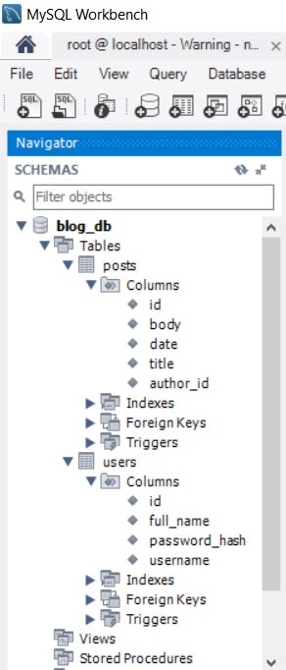

The **database** will be **empty**: no users, no posts.

After that **disable auto-table creation**:

|  |
| --- |
| src/main/resources/**application.properties** |
| *# Configure Hibernate DDL mode: create / update* **spring.jpa.properties.hibernate.hbm2ddl.auto** = **update** |

**Run** the project again. You are ready to **fill some sample data** in the database.

## Create Some Sample Data in MySQL (Users and Posts)

Put some data in the MySQL tables. Otherwise the home page will be empty (no blog posts).

You may use the **database script** from the resources coming with this lab. To **insert some users and** posts, execute the script db/Sample-data-users-posts.sql:

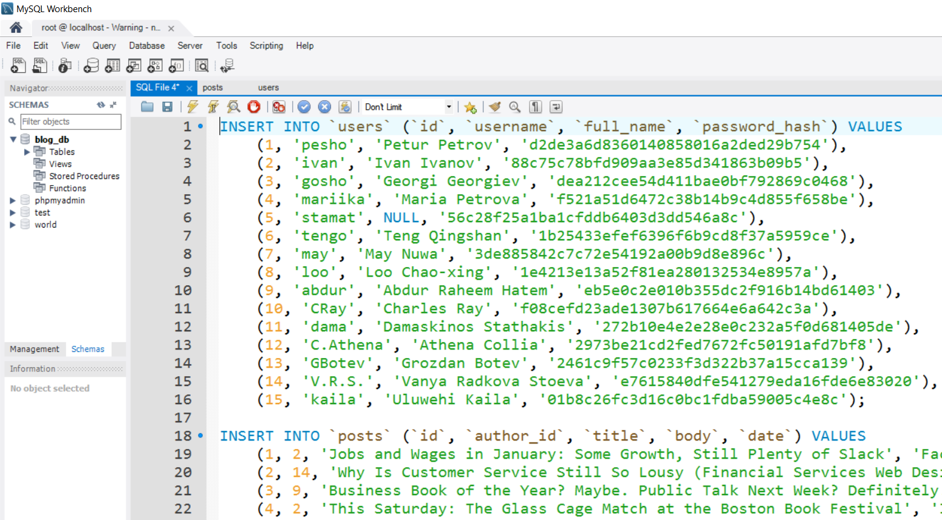

Check your database tables users and posts:

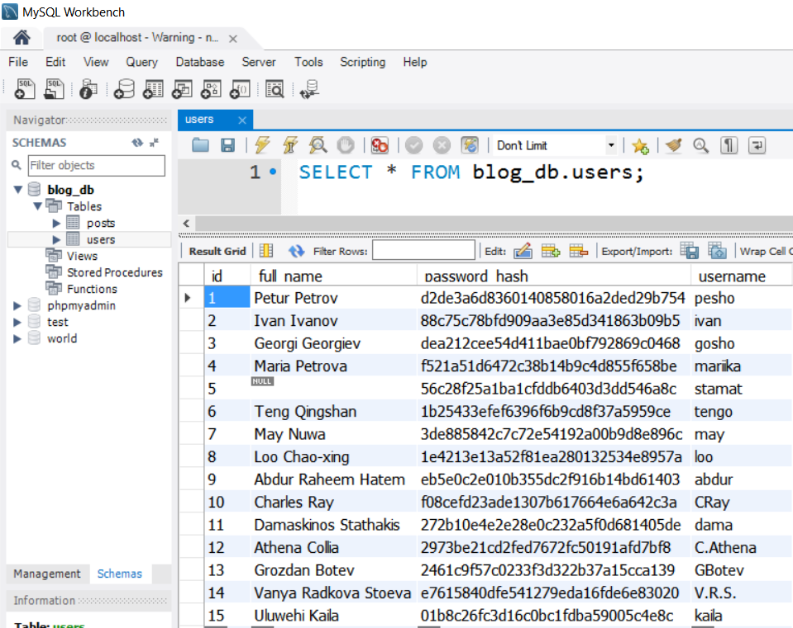

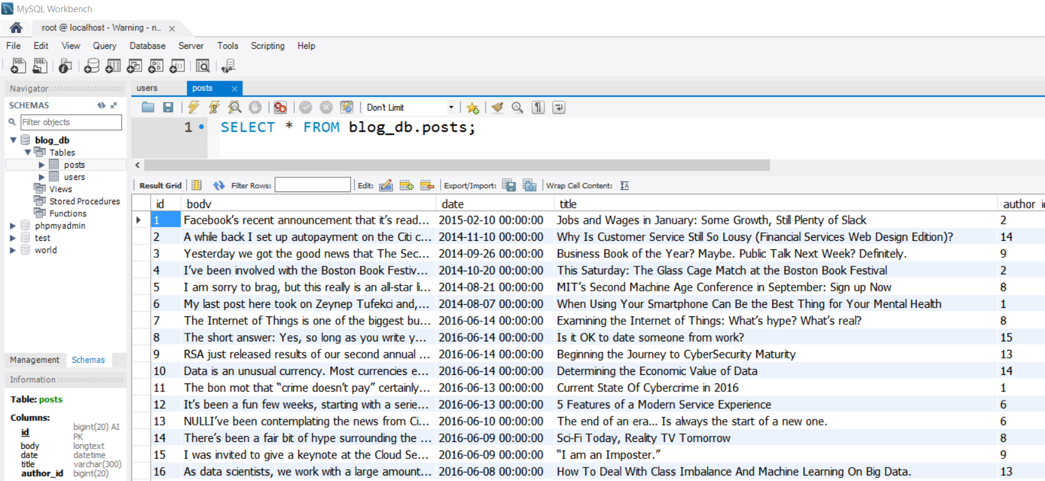

## Test the Sample Users and Posts Data from MySQL

**Run the application** again to test the sample data:

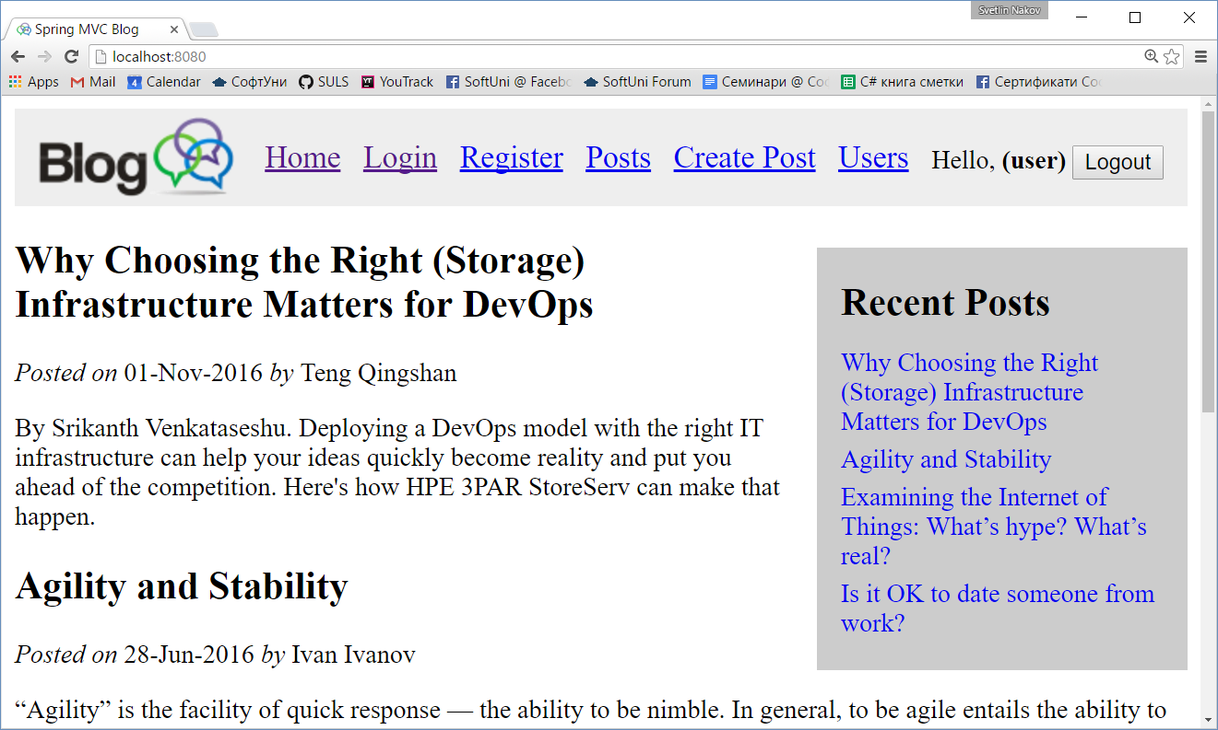

# Part IV: User Accounts with Spring Security

In this section we shall implement **user accounts** and access permissions, based on the **Spring Security framework**. This includes user **registration**, user **login**, user **logout**, authentication, authorization, access control, etc.

TODO: a lot of work will come here for the login / logout to be implemented using the Spring Security framework. You might check this article: <https://spring.io/guides/gs/securing-web/>.